5 Jobs Where Scaffolding is Essential

Scaffolding is without a doubt the backbone of modern construction, with many industries demanding its use. Scaffolding is essentially a temporary structure which is designed to support workers and materials in the construction, repair, and maintenance of structures. From this definition, it’s clear that various types of scaffolding have been used to build structures all across the world for thousands of years.

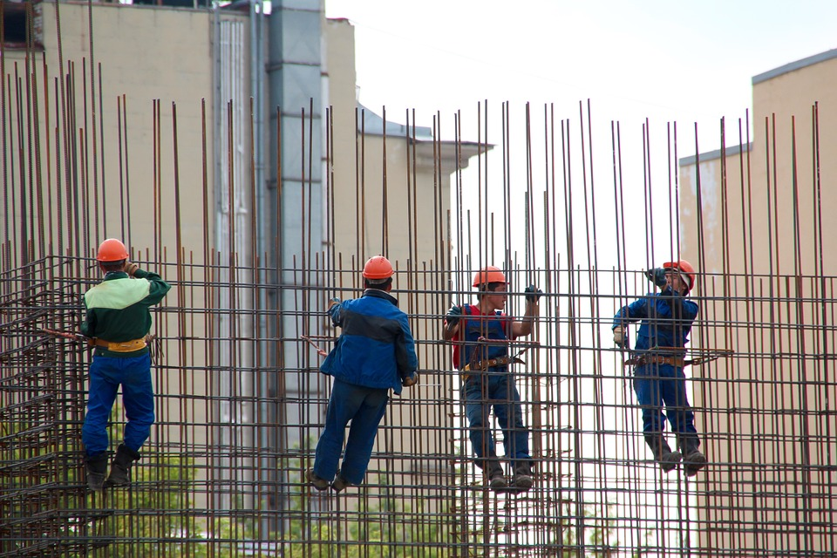

When working at heights, safety clearly becomes the top priority and a key concern for contractors. Despite the exceptional advancement of today’s technology, the construction industry (which heavily relies on scaffolding) is still one of the most dangerous industries with a significant percentage of accidents and injuries happening every year. As a result, strict regulations regarding scaffolding assembly and use, along with inspections and maintenance, have been implemented to try to increase the safety of workers on this equipment.

Today, there are many types of scaffolding used in a wide variety of industries. From high-tech, customised scaffolding used to create unique structures and monuments, to simple bamboo scaffolding which is still widely used in Asia. Depending on the type of work being performed, contractors have access to a wide range of scaffolding equipment, from single pole scaffolding, suspended scaffolding, birdcage scaffolding, and cantilever scaffolding to name a few. To give you a better understanding of just how important scaffolding has become in our society, let’s take a look at 5 jobs where scaffolding is essential.

Events & Entertainment



The events and entertainment industry require live concerts and event stages that can often reach huge heights, so scaffolding is required to construct these stages along with lighting and sound systems. In some cases, temporary grandstand seating may be the best option for outdoor arenas and considering that most modern scaffolding systems are modular in design, they can easily be constructed under, over, and around most of these project specifications.

Building Inspections

Once a building has been constructed, building inspections must take place to ensure the structure adheres to all safety regulations. Scaffolding is needed in building inspections so its infrastructure and other foundations can be examined thoroughly and safely. Sometimes a buildings infrastructure can reach hundreds of metres in height where safety becomes a key concern, and scaffolding provides the accessibility and safety required to enable these inspectors to perform their jobs.

Repairs & Renovations

Considering that few buildings and structures are rarely demolished these days, repairs and renovations is big business in Australia. Ensuring the structural integrity and safety of buildings and other structures is therefore paramount, and scaffolding is an essential component that allow workers to reach any area of these structures. Historical monuments and landmarks are typically very old and fragile, and repairs may be needed regularly to ensure a city’s culturally history remains preserved.

Window Washing

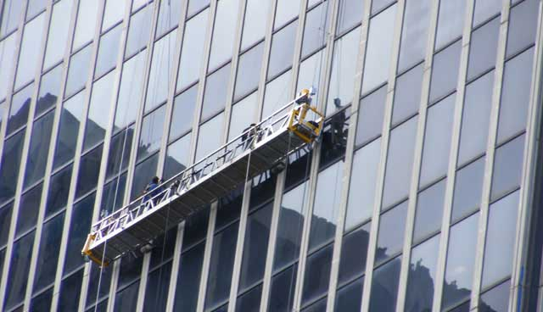

You’ve probably seen the suspended scaffolding that window washers use to clean the windows of tall commercial and residential buildings? Can you imagine trying to clean all these windows without suspended scaffolding!? Large hotels and other buildings that take immense pride in their appearance employ window washers regularly to clean (and even perform repairs) on their buildings.

Painting

Painting is another industry which heavily relies on the use of scaffolding. Painters often have to work at great heights and scaffolding is needed not only to provide support to workers and materials, but more importantly to increase their safety. While ladders can be used, they are limited in their height and lack the security features such as handrails and toe boards that scaffolding offers. Being able to move freely and safely around a scaffolding platform significantly increases the productivity and efficiency of painters.

There are many other industries where scaffolding is essential to enable workers tosafely and productively perform their jobs. Considering that safety is an integral issue with scaffolding equipment, it’s strongly recommended to rent or buy hire scaffolding from reputable suppliers only. If you’re interested in renting or buying scaffolding for your next project, reach out to the professionals at Uni-Span by phoning 1300 882 825.

